**Aim:- -** **Demonstrate the use of textbox, label and button controls for given windows applications**

1. Create an application that allows the user to enter a number in the textbox named  
   ‘getnum’. Check whether the number in the textbox ‘getnum’ is palindrome or not. Print the  
   message accordingly in the label control named lbldisplay when the user clicks on the button  
   ‘check’.

Code:

Form1.cs

using System;

using System.Collections.Generic;

using System.ComponentModel;

using System.Data;

using System.Drawing;

using System.Linq;

using System.Text;

using System.Threading.Tasks;

using System.Windows.Forms;

namespace WindowsFormsApp2

{

public partial class Form1 : Form

{

public Form1()

{

InitializeComponent();

}

private void button1_Click(object sender, EventArgs e)

{

int num = int.Parse(textBox1.Text);

int a, rev = 0, d;

a = num;

while (a > 0) {

d = a % 10;

a = a / 10;

rev = rev * 10 + d;

}

if (rev == num)

{

label2.Text = label2.Text + num + " is a palidrome number";

label2.Show();

}

else

{

label2.Text = label2.Text + num + " is not a palidrome";

label2.Show();

}

//20012011130_Patel Vandan

}

}

}

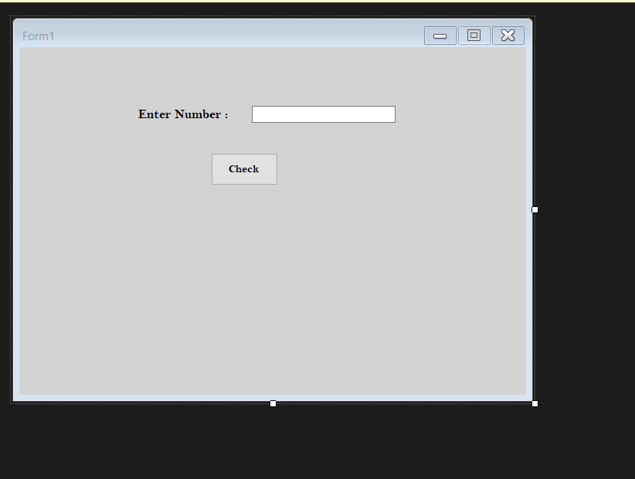

**Output:**

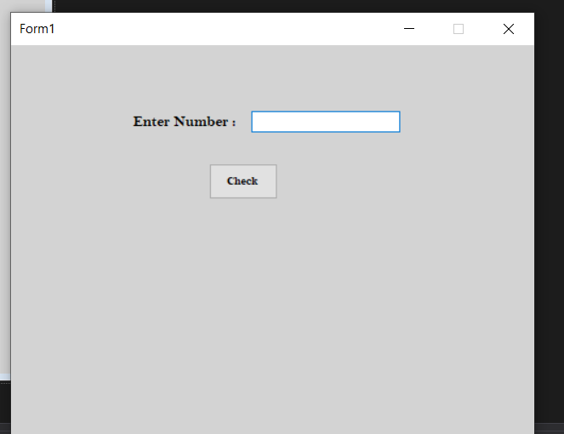

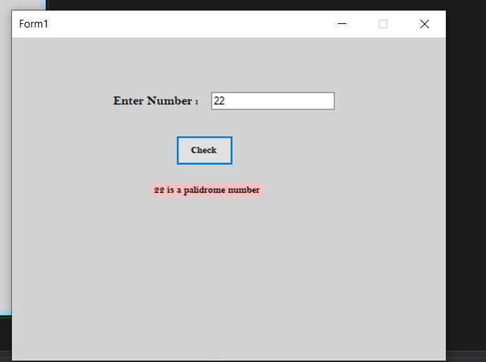

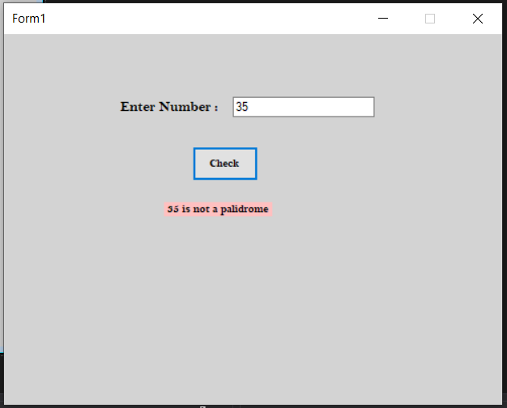

2.Develop windows form which has two textboxs to enter two numbers(range). Now find all the armstrong numbers between given range and dispaly all armstrong numbers in label.

Code:

Form1.cs

using System;

using System.Collections.Generic;

using System.ComponentModel;

using System.Data;

using System.Drawing;

using System.Linq;

using System.Text;

using System.Threading.Tasks;

using System.Windows.Forms;

namespace Practical6_2

{

public partial class Form1 : Form

{

public Form1()

{

InitializeComponent();

}

private void button1_Click(object sender, EventArgs e)

{

int num1, num2, n, sum, r;

num1 = int.Parse(textBox1.Text);

num2 = int.Parse(textBox2.Text);

for (int i = num1; i <= num2; i++)

{

sum = 0;

n = i;

while (n != 0)

{

r = n % 10;

sum = sum + (r * r * r);

n = n / 10;

}

if(sum == i)

{

label3.Text = label3.Text + i + " ";

label3.Show();

}

}

}

}

}

**Output:**

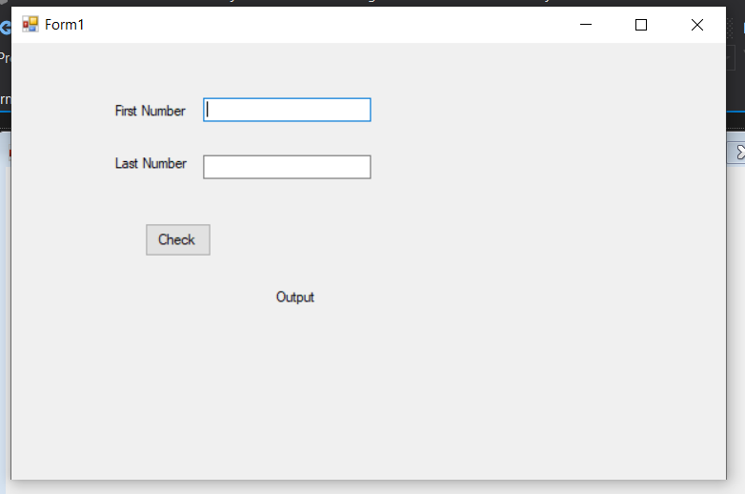

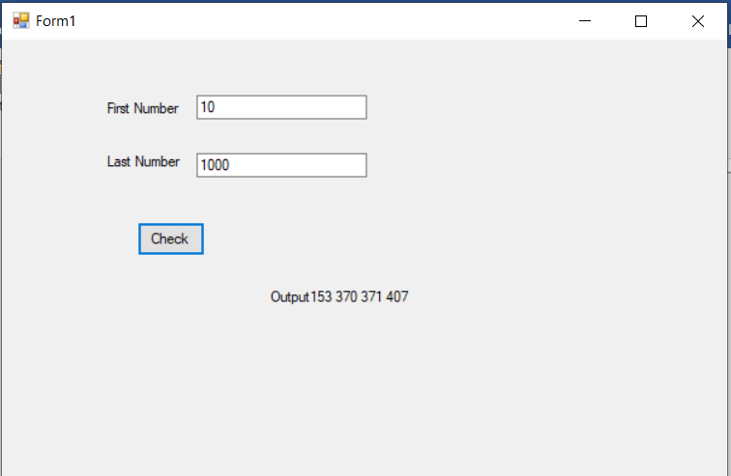

3. Create one form and three textboxs for mobile number, password and confirm password. Write a c# code for following:

(i) To validate mobile number

(ii) To check weather password and confirm password are same or not

(iii) To check each and every textbox should not be empty

Code:

Form1.cs

using System;

using System.Collections.Generic;

using System.ComponentModel;

using System.Data;

using System.Drawing;

using System.Linq;

using System.Text;

using System.Threading.Tasks;

using System.Windows.Forms;

using System.Text.RegularExpressions;

namespace Practical6_3

{

public partial class Form1 : Form

{

public Form1()

{

InitializeComponent();

}

private void button1_Click(object sender, EventArgs e)

{

label4.Visible = false;

label5.Visible = false;

Regex rm = new Regex("^[0-9]{10}$");

Regex rp = new Regex("^(.{6,12}|[^0-9]|[^A-Z]|[^a_z])$");

string m = textBox1.Text;

string p = textBox2.Text;

string cp = textBox3.Text;

if (textBox1.Text == "" || textBox2.Text == "" || textBox3.Text == " ")

{

MessageBox.Show("Error");

}

else

{

if (rm.IsMatch(textBox1.Text.Trim()) == false)

{

label4.Text = "please enter correct number";

label4.Visible = true;

}

if (textBox2.Text != (textBox3.Text))

{

label5.Text = "enter correct password";

label5.Visible = true;

}

}

}

}

}

Output:

